BIODATA

“The secret of education lies in respecting the students.”

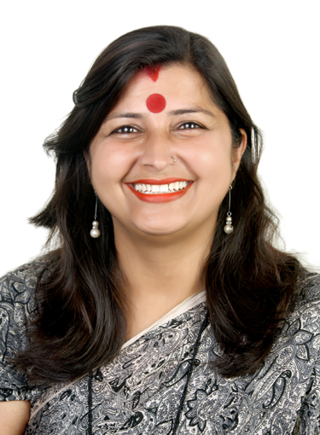
Dr. RACHNA SHARMA
PhD(H/C)
TGT English & NCC OFFICER
E-mail: srachna@ymail.com.
Mobile: 09419724045, 07006714035.

OBJECTIVE: - To better facilitate students’ learning in the area of ENGLISH & NCC and enable them to work individually as well as in TEAM.

- Summary of skills:

- Keeping abreast of developments in the field by reading current literature, liaising with colleagues, and participating in professional workshops.

- Exceptional communicator with teachers, staff, students and parents demonstrating a caring and empathetic attitude, promoting the welfare of the institution.

- Deep knowledge of ENGLISH & NCC and strong interest in teaching English & NCC subjects.
- Excellent communication and written skills.
- Ability to plan the lessons and deliver them efficiently to the students.
- Ability to make use of different teaching methods like demonstration, role playing etc. with the help of ICT Tools.
- Capable of making use of Computer aided learning and Technological aided learning both for teacher and students.
- Capability to maintain good relationships with students as well as inspire them to perform well.
- Highly skilled in planning the strategies and applying them for the development of students.
- Strong interpersonal as well as organizational skills.
- Ability to discuss with students on their academic problems.
- Capacity to solve problems efficiently and effectively.

- Educational qualification :

DEGREE | NAME OF THE BOARD/UNIVERSITY | SUBJECTS TAKEN | MARKS OBTAINED | %AGE
12TH | JKBOSE | ARTS (H Sc) | 352/600 | 59
B.Sc ( H .Sc) | Jammu University | Home Science | 484/800 | 60.5
M.Sc. (H. Sc) | Jammu University | Homescience | 1486/2400 | 61.9
B.Ed | Jammu University | Teaching of Science & English | 651/1100 | 59.18
MA (ENGLISH) | Jammu University | ENGLISH | 835/1600 | 52.19

- Professional Experience:

Having an experience of more than 20 years of teaching English to classes VI to XII in senior secondary Army Public School Jammu Cantt, Jammu.

- Conducted various time classes in Camps .
- Conducted various orientation programmes for teachers in APS Jammu Cantt and students.
- Helping new teachers to settle and understand the organization.
- Designing of latest pattern question papers with the help of ITC Tools.
- Provide Subject material commerce sample papers model test papers to teachers with in the Jammu city and outside also.
- Providing course material to the students so that they can study by themselves.
- Offering guidelines to every individual for his/her development.
- Inspiring students, getting them into discussions, and developing their skill sets.

- Additional responsibilities:

- Working as a NCC OFFICER FOR JW from NOVEMBER 2015 to till date.
- Helped in Organizing annual days and sports days in the school.
- Conducted counseling for the students of class IX to XII for the last two years.
- Working as HOD English.
- Working as Incharge of Environment Club.

- Awards and Achievements:

- Awarded Best Assosiate NCC Officer award by J&K Directorate for the year 2018.
- Attended Training Course at OTA Gwalior from 16 August – 16 Nov 2016. Got two Certificates of excellence , one in Cultural and one in Institutional Planning.
- Got Director General NCC Commendation Award in Jan 2018 at Republic Day Camp at Garrison Parade Ground.
- Attended Refresher Course at OTA Gwalior from 10 June – 10 July 2019. Out of 123 NCC Officers from all over the India got 2nd position ,Silver medal, Got two Certificates of excellence , one in Exercise Shakti and one in Exercise Anubhav ,Institutional Planning.
- Got Bharat Ratan Mother Theresa Award for her exemplar performance in NCC on 26 August 2019 at Hyderabad.

- Awarded ‘Global Peace Award’ on International Peace Day on 21 Sep 2019 by Subedar Amir Ali Khan Global Peace Foundation & Trust at Telangana.

- Got ‘ACHARAYA CHANAKYA SHIKSHAVID SAMMAN” on 5th September 2020.

- Awarded as ICONIC EDUCATIONIST of the year 2020-21 by PEFI and BTC India.

- Awarded Honorary Doctorate Degree , Doctor of Philosophy in Education by Theophany University on 12 June 2021 on Virtual platform.

- Conferences / Workshop Attended:

- Training on Life Skills and Personality Development , organized by Rajiv Gandhi National Institute of Youth Development, at NCC OTA Gwalior 24-25 October 2016.
- Presonality Development and Communication Skills, organized by Department of English of Government Degree College, Udhampur 28 July 2019.
- Learn 100 WOW Teaching Ideas , organized by CED Foundation Trust at India International Centre , Lodhi Road- New Delhi ,8 September 2019.
- Presented Paper at International Seminar , Unravelling The Mind’s Eye.31 Oct 2019.

- Areas of Interest:

- Innovating different interesting approaches to make learning of English a real fun.
- Applying the self strategies for achieving the goals of an organization.
- Providing awareness of English subject in Jammu city for both teachers and students.
- Exploring new methods, techniques applications in android related to English subject.
- Hobbies:

- Playing Sports
- Taking Career Counseling and Motivational Classes for the students
- Exploring different educational websites.

- Personal Details:

- Name: RACHNA SHARMA
- Date of Birth: 15/08/1975
- Employment Status: Full time
- Relationship status: Married

- RACHNA SHARMA
D/O BODH RAJ SHARMA (Ex IAF Officer)
W/O KARUN KHARBANDA (Bussinessman)
H No 169 , KANAK MANDI
JAMMU-180001
JAMMU AND KASHMIR

